All image files have been renamed to help data-tracking and analysis.

Large file names become difficult to read. As images are processed file names are appended to image analysis results so the problem can become exacerbated at each processing step

Here the ID code for P13121 is as follows:

Site | Year | Collection | Grid | Day
P | 13 | 1 | 2 | 1

The integrity of original date:time sequences for files in each of the folders are double checked before renaming.
pyRenamer 0.6.0 for Ubuntu 14.04 (64bit) was used to rename files in bulk.
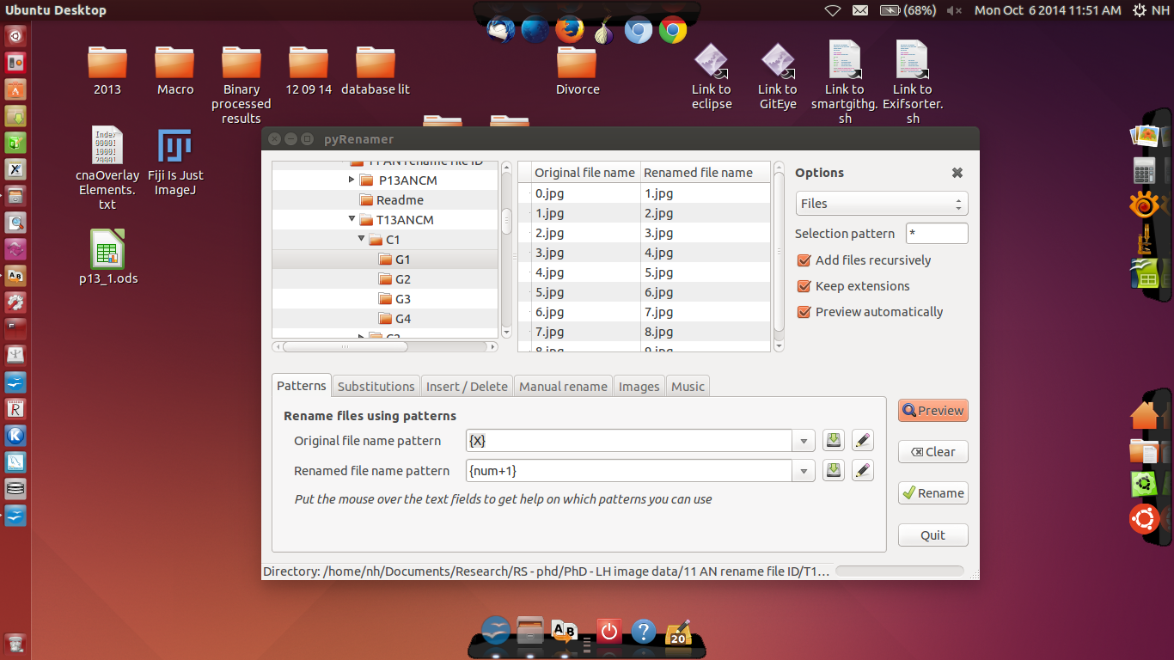
Summary of file ID's
- IN CM – inactive nests using constructed standard of measured
- M13ANCM – Memorial Drive, 2013, active nests using constructed standard of measure
- P13ANCM – Mt. Parihaka, 2013, active nests using constructed standard of measure
- T13ANCM – Mt. Tiger, 2013, active nests using constructed standard of measure
  - C – collection number (1 - 4)
  - G – grid number (1 - 4)

